Autumn, Mandy, Jacob

Cross Word

Intro: For this project we are going to create an interface that will generate a cross word puzzle board and allow the player to solve it and it would the tell the player they won and give an option to play again. There will be a word bank of 100 words and the board will have different levels easy will have 10 words, medium will have 15, hard will have 20, and expert will have 25. Each of these levels have a timed and not timed option.

IO: The user will see a window with boxes indicating where words are and a small number in the first box to indicate what hint corresponds to that word. The questions will be numbered even will be down and odds are across. The game will auto check the input from the user and tell them if the word is correct or not. From there will be multiple buttons at the top a clear board button, new board button, and hint button. There will also be a “?” mark button that when clicked will show instructions. From there we will have a timer at the top for timed levels. Here is a diagram of how the pop-up board will look:

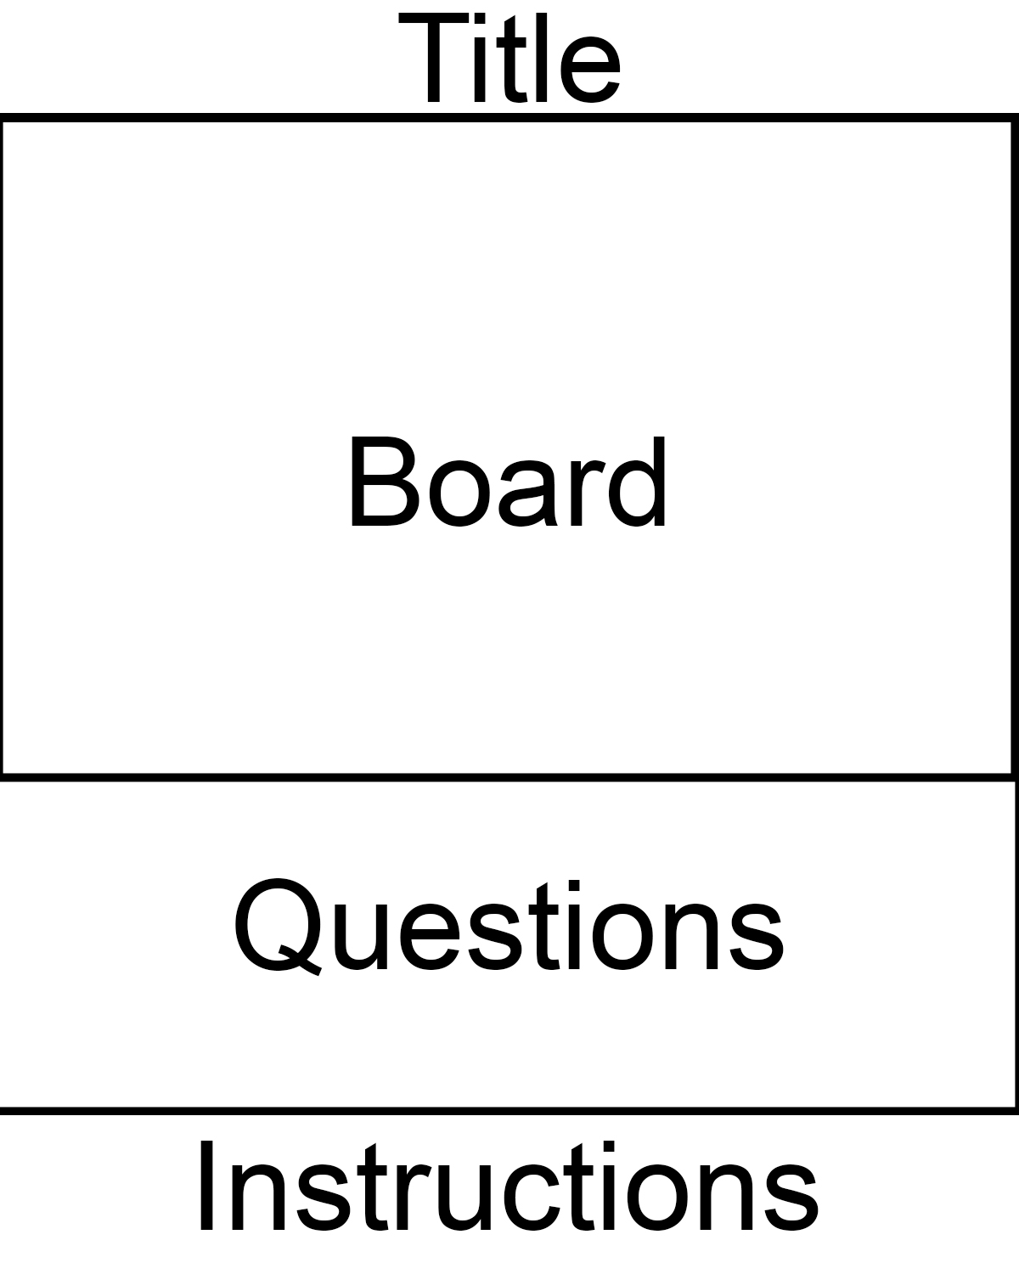

DD: There are a few specific features we want to focus on. The board, how the game restarts, and how the game is played. So, starting with the board we will have the game open in a separate window and from there the board will have boxes/lines to indicate where the words are and how long they are. The first box will contain a number that will not affect the game but indicates the question the corresponds to the word. There will be a title at the top. we intend to have at least a new board button/function that can be called but we hope to include more. There will be instructions underneath the questions for the words on the board.

There are two main details besides creating the board that we will focus on the first is how the game restarts. The game will restart either when the player has won or if the ask for a new board. It is important that they then don’t receive the same board a second time and from there we need to also focus on how you play the game do you input directly on the board or do you input from idle what word you are inputting and the word itself. We are going for the second option. So, from idle you will input: (word number, word) and if the word is correct it will be replaced on the board if not you will be prompted to try again.

Scope: There are multiple complicated factors and aspects to the game we have proposed so to start off with our main goal is to have a working easy level that is not timed. From there we will add levels and the timer depending on issues that arise and our due date. The buttons proposed may be limited to just a new board button also pending on issues and due date. There will absolutely be instructions, questions for words, and labels for both the questions and the first box of the word. We may decide later as well to have all levels timed or not timed and not have a user option. The biggest issue is to not bite off more than we can chew. So, we will start small and grow the project from there. We will start with an easy untimed level that restarts when the game is won and build from there adding levels and functions that allows the player to restart with a new board and even receive a hint, more levels, and a timed level option.

Extra Inputs:

a menu that allows you to pick a theme

different difficulty of questions